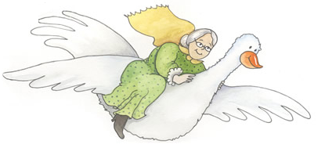

Goslings
Parent/Family Post Questionnaire

Today's Date: / /

Read the statements below and circle the answer that best applies to you:

 | Strongly disagree | Disagree | Neither agree nor disagree | Agree | Strongly agree
1. I am satisfied with the Mother Goose program. | 1 | 2 | 3 | 4 | 5
2. The Mother Goose program provided me with skills and materials to help baby’s early literacy and development. | 1 | 2 | 3 | 4 | 5
3. The program informed me of the importance of talking to the baby | 1 | 2 | 3 | 4 | 5
4. The program informed me of the importance of reading to the baby | 1 | 2 | 3 | 4 | 5
5. The program taught me about baby signals of readiness for interaction. | 1 | 2 | 3 | 4 | 5
6. The program made me feel more confident that I can read the baby’s cues. | 1 | 2 | 3 | 4 | 5

7. How likely would you be to recommend this program to other parents/families of babies in the NICU?

1 | 2 | 3 | 4 | 5
Extremely unlikely | Unlikely | Neutral | Likely | Extremely likely

8. What did you like most about the program?

9. If you could, what would you change about the program?

10. Would you recommend that the NICU offer this program again?

__Yes __No

During the coming week, how often do you intend to:

 | Not at all | 1-3 times a week | 4-6 times a week | Every day | Several times a day
11. Talk to the baby in the NICU | 1 | 2 | 3 | 4 | 5
12. Read books to the baby in the NICU | 1 | 2 | 3 | 4 | 5
13. Recite nursery rhymes to the baby in the NICU | 1 | 2 | 3 | 4 | 5
14. Sing to the baby in the NICU | 1 | 2 | 3 | 4 | 5

