**Oakland California MGOL Training 2015**

Brain Research – with Dr. Betsy Diamant-Cohen

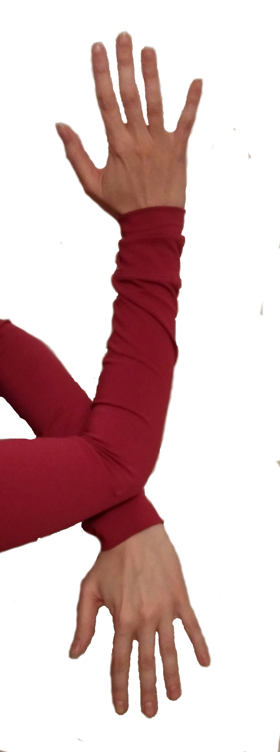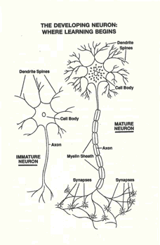Neurons

Synapse = connections

First relationships

Limbic system

Three brains in one

Brain chemistry

Pruning

**Oakland California MGOL Training 2015**

Brain Research – *Optimal thinking outside of the box can happen anywhere; in the car, in the house, in the library, in the store*

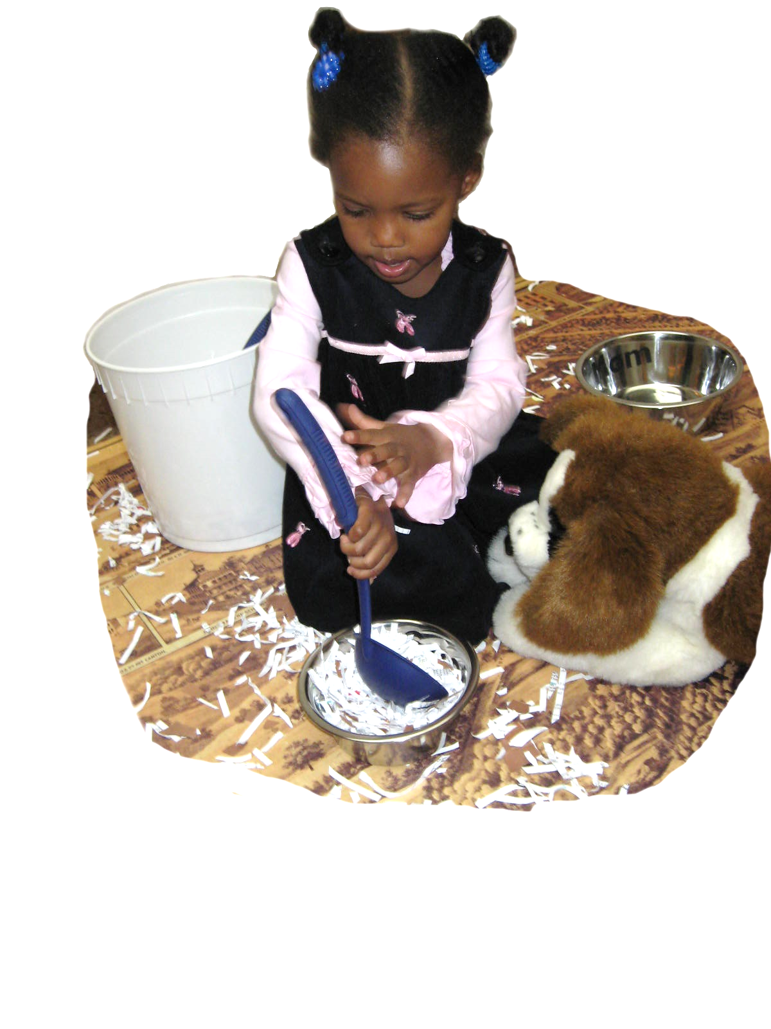

Optimal learning environment:

* Environment
* Hands-on learning
* Repetition & ritual
* 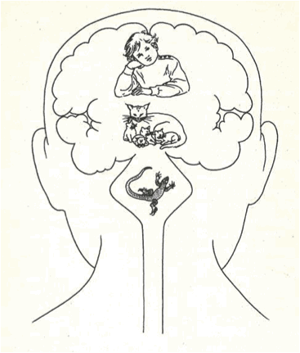Movement
* Music
* Play
* Connection

**Oakland California MGOL Training 2015**

Mother Goose on the Loose

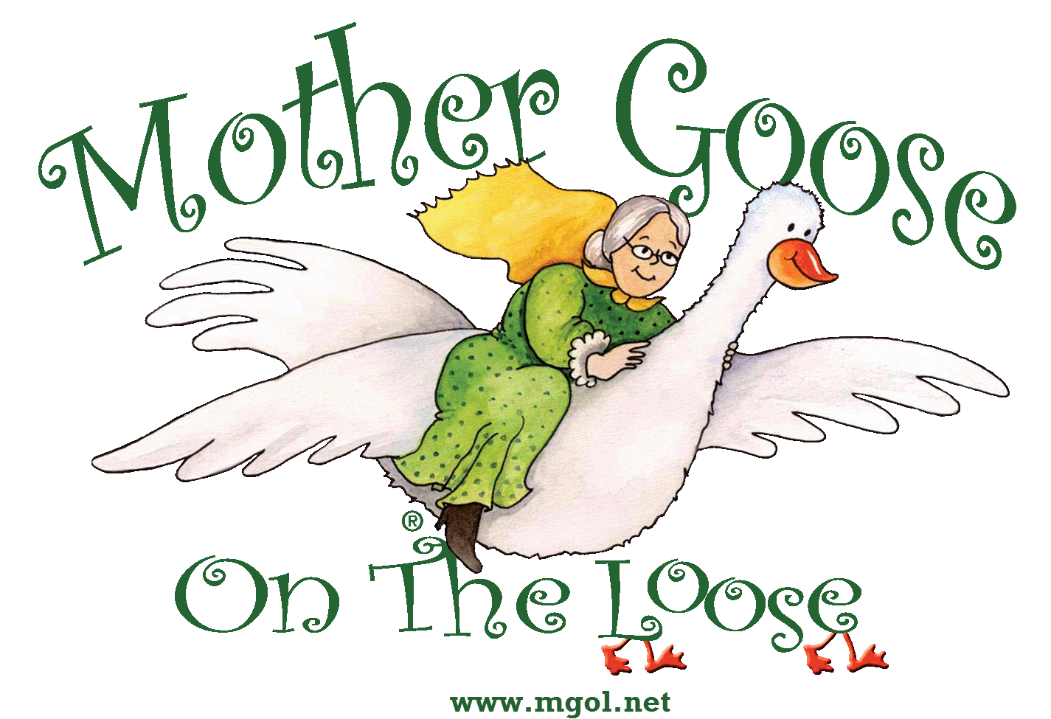

Secret Formula: 80% Repetition

Librarian as Facilitator

Includes:

* Material by Barbara Cass-Beggs
* 2 developmental tips
* Positive reinforcement activities

Ten sections

1. Welcoming Comments
2. Rhymes & Reads
3. Body Rhymes
4. Rum Pum Pum Drum Sequence
5. Stand-Up Activities
6. Animals
7. Musical Instruments and Colored Scarves
8. Lullaby
9. Interactive Rhymes
10. Closing Songs

**Oakland California MGOL Training 2015**

Early Learning Standards

Health, wellness, and physical development

Social and emotional development

Cognition and General Knowledge

Social studies thinking

Scientific thinking and technology

Mathematical thinking and technology

Creative thinking and expression

Approaches to learning through play

Language and literacy development

**Oakland California MGOL Training 2015**

School Readiness & Every Child Ready to Read @ your library ®



The six foundational skills to get ready to read:

* Print motivation
* Vocabulary
* Narrative skills
* Phonological awareness
* Print awareness
* Letter knowledge

**Oakland California MGOL Training 2015**

School Readiness & Every Child Ready to Read @ your library ®

*Five simple practices help every child get ready to read.*

* Talk
* Sing
* Read
* Write
* Play

**The importance of school readiness**

**Oakland California MGOL Training 2015**

21st Century Skills

The 4 C’s:

* Creativity
* Critical Thinking
* Collaboration
* Communication

**Oakland California MGOL Training 2015**

Activity Ideas and Developmental Tips