RegisĞraĞion Form
DaĞe:

First & Last Name
Contact Information
(Email and phone)
Any special needs?
(i.e. translator, accessibility, etc.) Baby’s due date

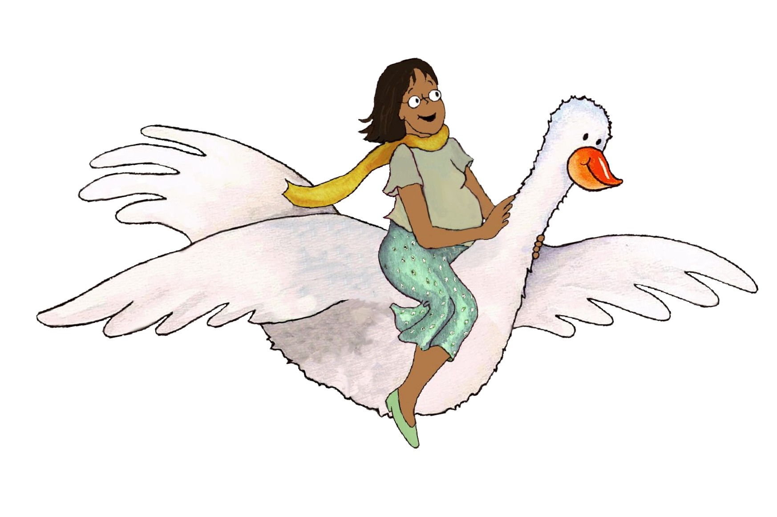
1.

2.

3.

4.

5.

6.

7.

8.

9.

10.

11.

12.

13.

14.
MGOL Hatchlings: Ready to Hatch | 67

