RegisĞraĞion Form

*DaĞe:*

First & Last Name

Contact Information

(Email and phone)

Any special needs?

(i.e. translator, accessibility, etc.) **Baby’s due date**

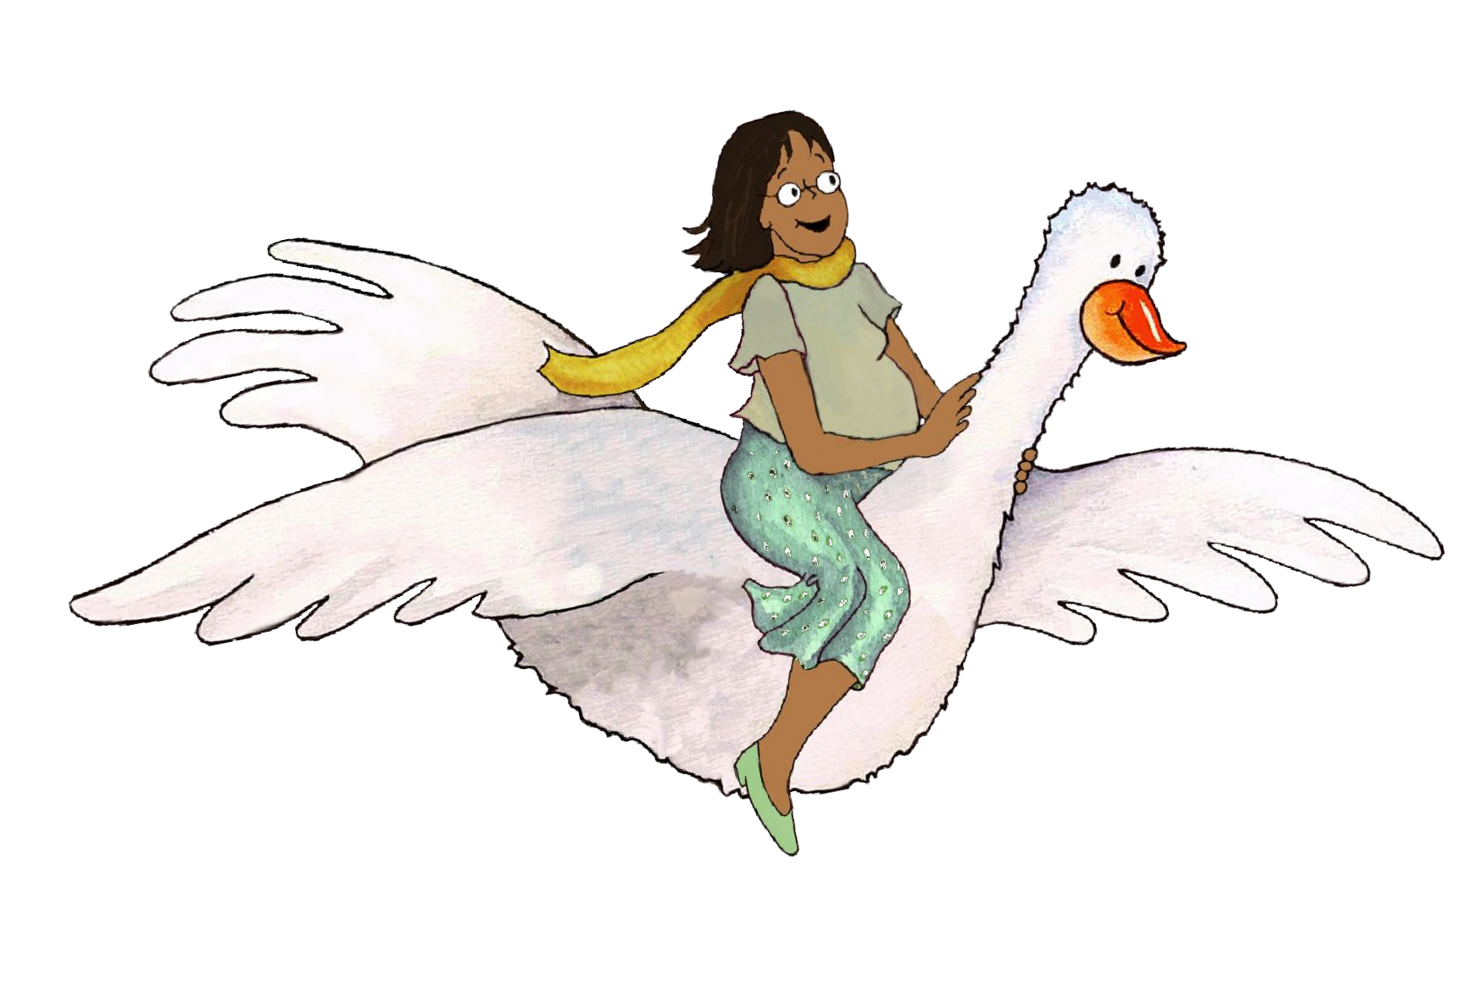

1.

2.

3.

4.

5.

6.

7.

8.

9.

10.

11.

12.

13.

14.

*MGOL Hatchlings: Ready to Hatch* | 67