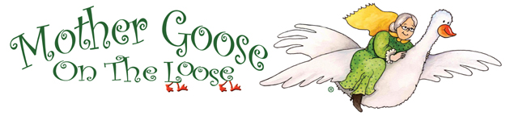
Refresher Agenda

- Welcome and Introductions
- Quick Brain Research Recap
- Early Literacy & Hot Topics
- Sample Program
- Sharing Rhymes, Songs, & Ideas
- Discuss Practices
- Questions and Brainstorming
- Celebration

